**Geointelligence Tutorial: Google Fusion tables**

**What is Google fusion tables?**

Fusion Tables is an experimental data visualization web application to gather, visualize, and share data tables. Non previous training is needed to combine available data owned from different parties to accomplish new tailor-made tables and neat products. Several resources and training material are available in the web to help you get the most of the web application. The main advantages are considered below:

* Visualize bigger table data online
* Merge your data with other people’s data
* Make a map in minutes
* Compatible file extensions such as .csv, .xlm and kml
* Host data online without compromising your information

**Goal #1:** Create a map of Italy by building a new database from two *Google Fusion Tables*. Find one dataset with demographic/territorial information and merge it with the geospatial location of the 20 Italian Regions.

1. First of all sign in to your Google Account or create a [Google Account](https://accounts.google.com/SignUp?service=fusiontables&continue=http%3A%2F%2Fwww.google.com%2Ffusiontables%2FHome) if you don’t have one.
2. Go to the [Google Tables website](https://research.google.com/tables) and search the keyword ***“Italy”***, select the source from Wikipedia, export to Google Sheets.

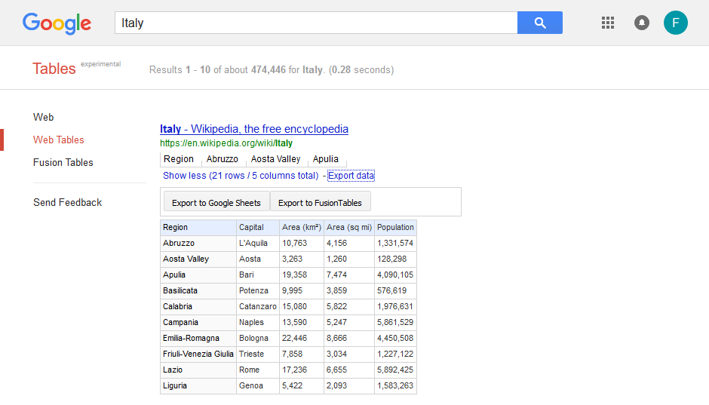

**SEARCH BAR**

**DEMOGRAPHIC INFORMATION**

**THE INTERFACE ENABLES YOU TO GO BACK TO GOOGLE BROWSER OR SEARCH ON GOOGLE TABLES**

**LOG IN**

1. The demographic information has been found but the file lacks geospatial data. In a **different search window** click on Fusion Tables and type ***“Regioni Italiane (KML)”***. Open the file to confirm the table contains geospatial coordinates of each region are correct and well represented in the map.

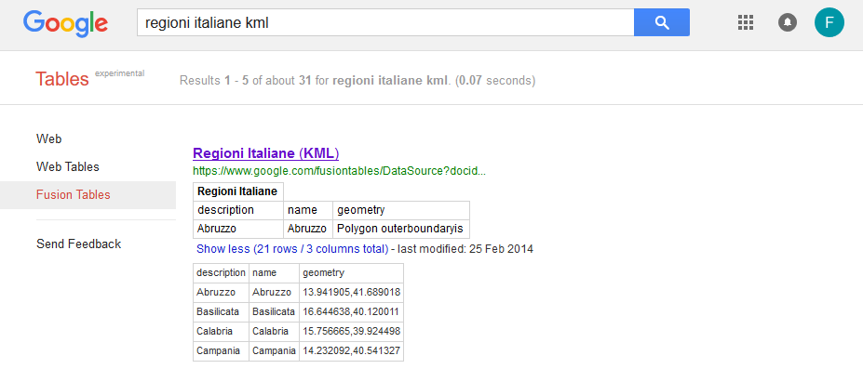

**GEOSPATIAL INFORMATION**

1. To view the map click on **Map of geometry**. The Map of Italy will appear on your screen, this means that the geospatial data is correct. Look at the image below:

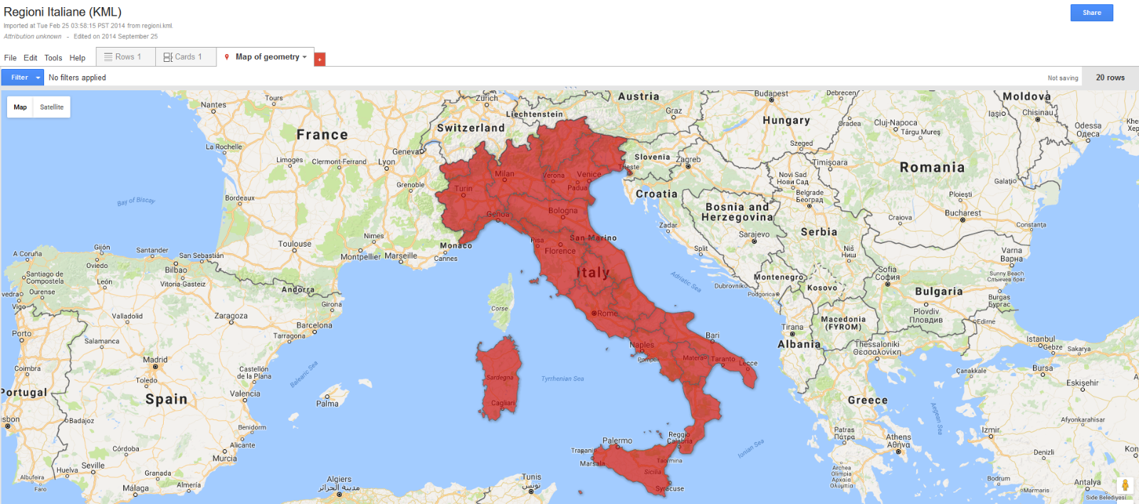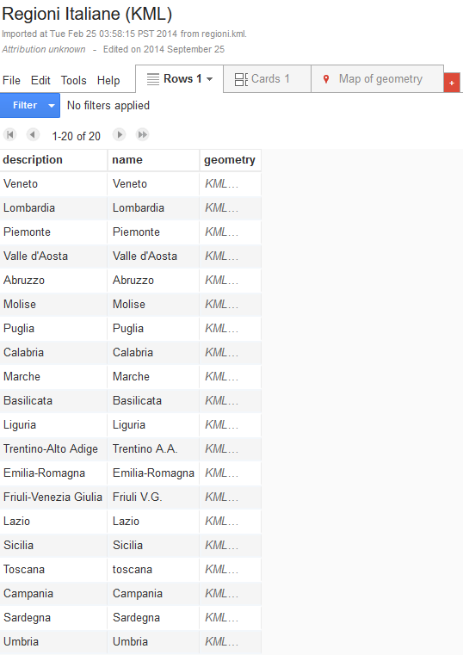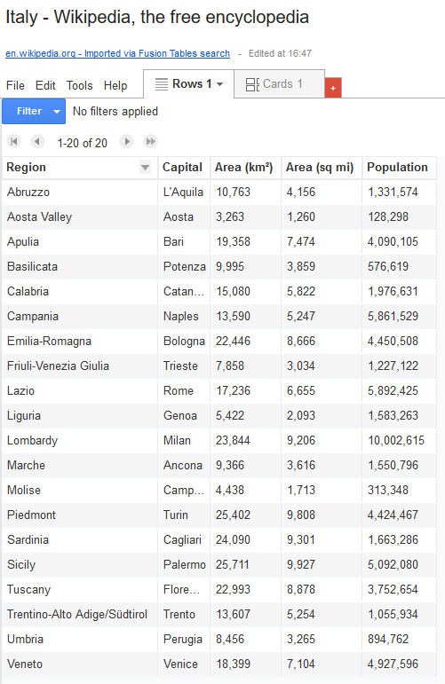

**ALL REGION NAMES DONT MATCH!**

1. Before merging or editing any information from the datasets, it is important to make a copy of each file. To do this, click on file and select **“make a copy”**. Rename both files to make sure that you are using the most recent data versions.
2. Now have a look at both tables and see which column match each other to **create the association**. In this case the column ***“Region”*** and ***“Name”*** are the most similar but some names doesn’t match because the columns are written in different language. To solve this issue use the column ***“Region”*** as reference and change the column description from the ***“Regione Italiane”*** file.

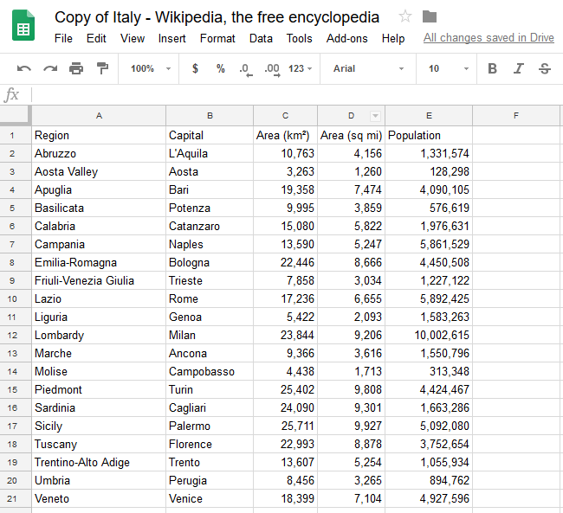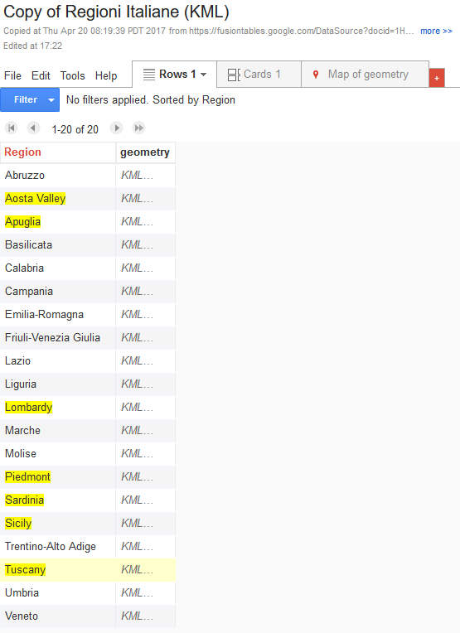

**Google Spreadsheet**

**Google Fusion Table**

1. After completing the editing work on both tables, it’s time to transform the file ***‘Italy’*** from Google Sheets to *Google Fusion Tables*. Click [here](https://fusiontables.google.com/DataSource?dsrcid=implicit) to select the file.

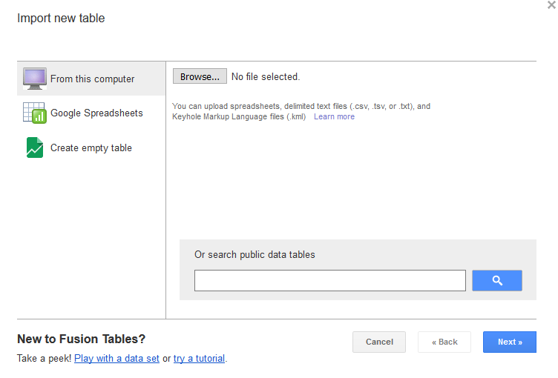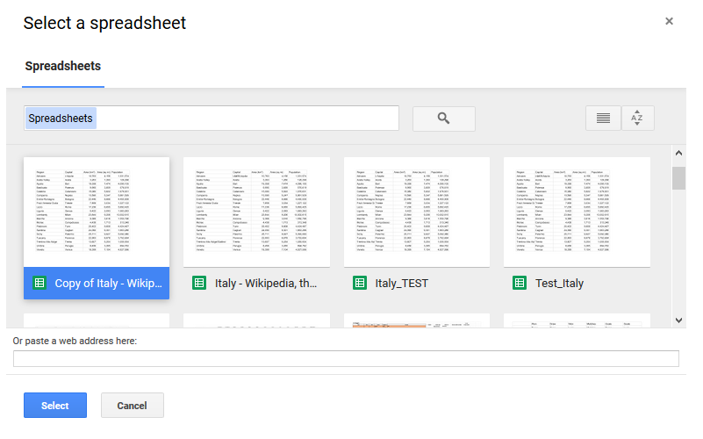

1. To finalize the work, choose **“find a table to merge”**, then select the file ***“Italy”*** from google drive and confirm the column association to merge both files.

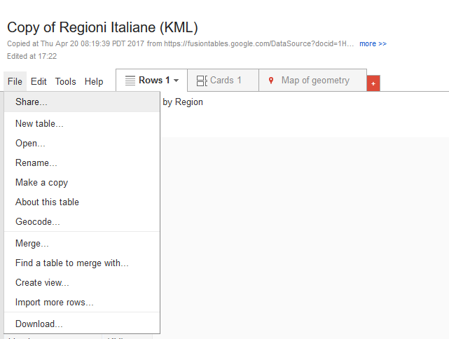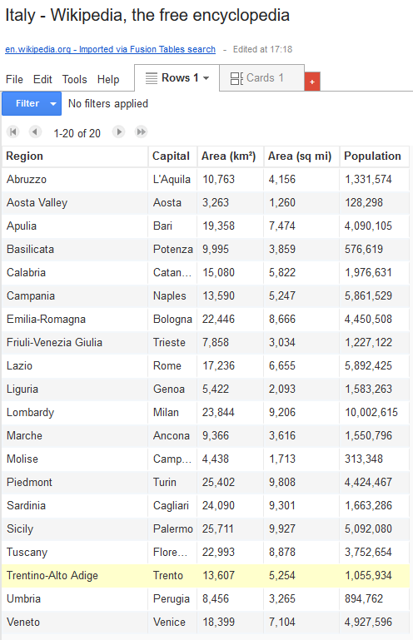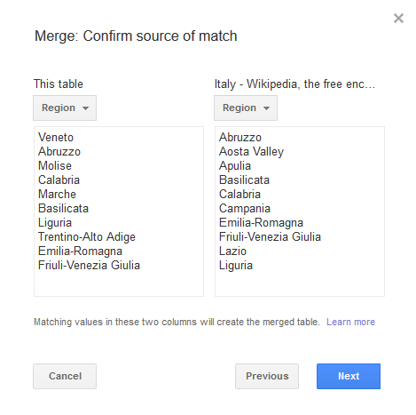

1. The final product should look like this. For reference purposes we will call this project **“Population in Italy”**

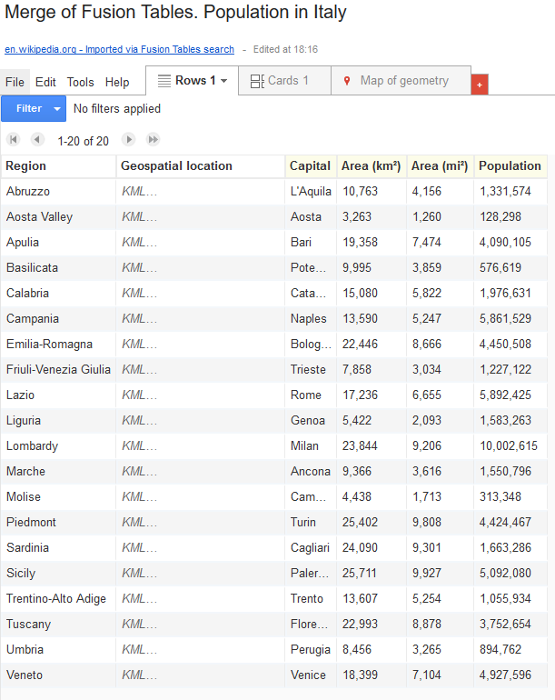 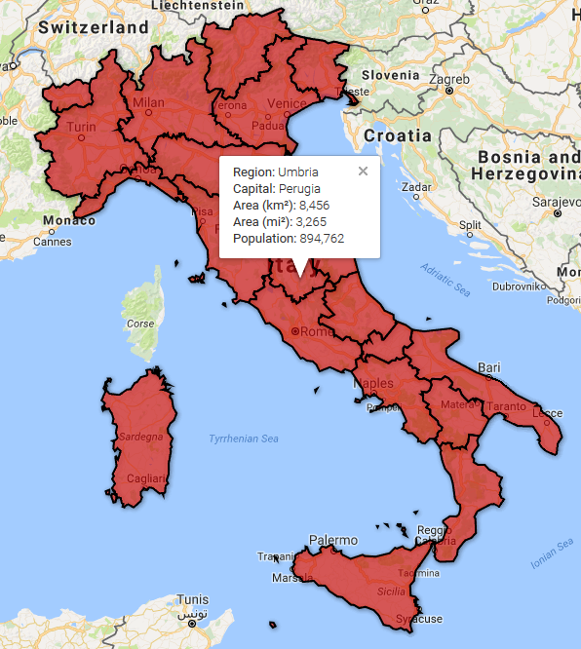

Note: Remember to improve the visualization of your map by changing the features, to filter the data and customized the pop-up information. Indicators can be added at any time by repeating the previous steps or by exporting a spreadsheet from your computer.

Congratulations!

You have successfully **completed** section #1 of the tutorial.

**Goal #2:** Create a new database about environmental risks in Italy from an official source and link it to Google Fusion Table **“Population in Italy”**.

1. Before start looking for new information, make sure you bookmark the Fusion Table **“Population in Italy”** or simply leave it open. You will receive new input to add more data to the list.
2. Now, depending on your current level of expertise, select one of the following methods to continue with the tutorial:

* **Beginner:** Use the **ready-to-go dataset from *Google Fusion Tables***. and continue the tutorial from point 6. To open the data click [here](https://fusiontables.google.com/DataSource?docid=10yenubm9wEe4FB8AQ5aOYNqH209ZilKqadYUjgtE#rows:id=1).
* **Intermediate:** Use the table available at the end of this tutorial and continue from point 6.
* **Advance:** In case you have previously worked with open data and have a general knowledge of Google Tables, follow steps 3, 4 and 5.

1. Open a new tab in Google and type “***Dissesto Idrogeologico in Italia”*** (Hydrogeological Risks in Italy) to download the official 2015 report from The National Institute for Environmental Protection and Research, ISPRA. If you would like to know more information about the ISPRA report click [here](http://www.isprambiente.gov.it/files/eventi/eventi-2016/frane-alluvioni/Sintesi_Rapporto_Dissesto_Idrogeologico_ISPRA.pdf).
2. Once you visualize the website, click in ***“scarica la pubblicazione”*** to download the publication in PDF format. Compile a form if needed.

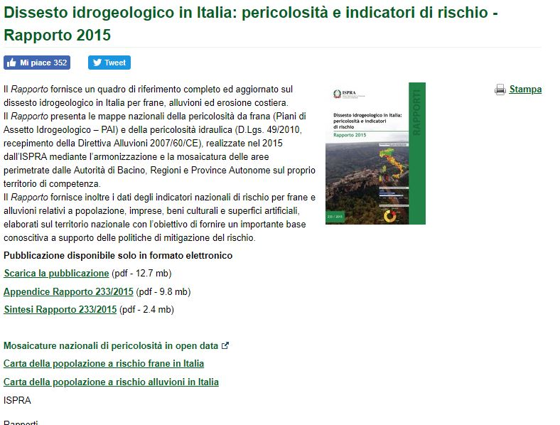

1. Create a new file excel with the name **“Risks in Italy”** and build a new table by copying the statistics of landslides and flood risk in the country published in the ISPRA report. Create the new database base on the following indicators:

* *Superficie regionale; pericolosità da frana elevata (P3) e molto elevata (P4);*
* *Pericolosità idraulica media (P2); numero totale di comuni per Regione;*
* *Comuni con pericolosità da frana (P3/P4) e/o pericolosità media idraulica (P2);*
* *Superfici con pericolosità da frana (P3/P4) e pericolosità media idraulica (P2);*
* *Patrimonio culturale a potenziale rischio di frana (P3/P4);*
* *Patrimonio culturale a potenziale rischio idraulico (P2)*.

**Note:** Considering that **Goal #2 aims to map only regional data**, disregard the data from the autonomous provinces Trento and Bolzano. Be aware that the Regions of Italy are listened in Italian in the ISPRA report. Make sure **the names of each Region are the same** as in the previous project, therefore homogenize the names to English. The expected list should look like the table at the end of the tutorial (next page).

1. The next step is to bring **“Risks in Italy”** into a Google Fusion table. To do this go back to **“Population in Italy”,** click on File, new, upload the spreadsheet from your computer and confirm the information. The table “Risks in Italy” will appear on the screen.

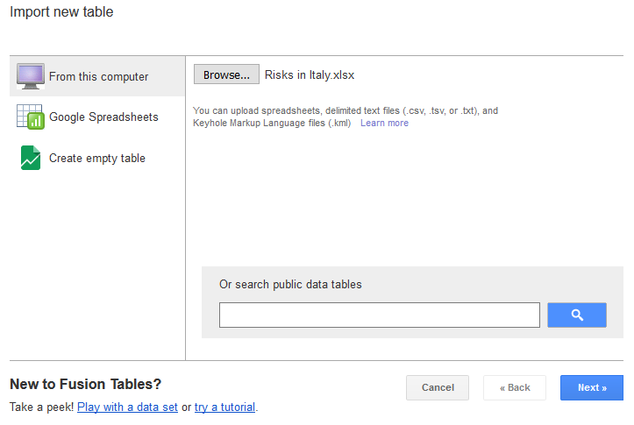

1. Let’s now merge both **“Population in Italy”** with **“Risks in Italy”** by following step #7. Rename the name as “Fusion Tables_Landslide and Flood Risk in Italy”. A good example of this would look like the following:

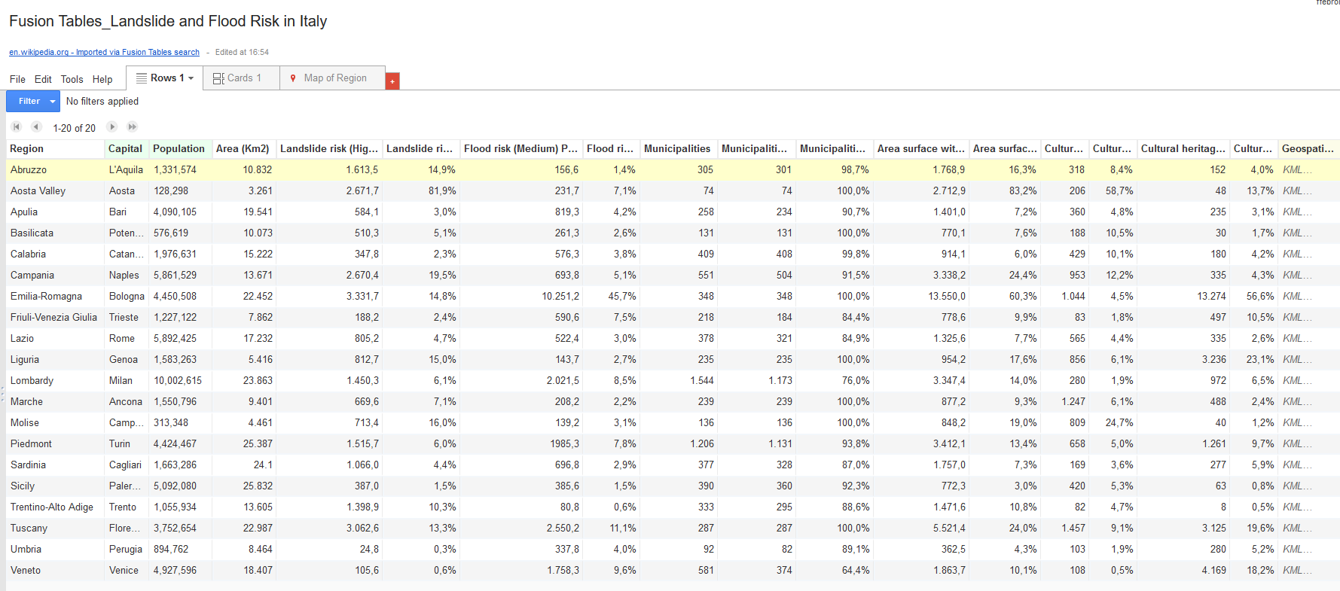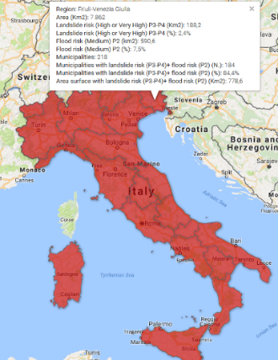

1. Now it’s time for you to play with the database and create different maps. To map the landslide risk in Italy click on change feature styles, fill color and select the corresponding like the following example. Tailor as much as you prefer. Don’t forget to include the legend!

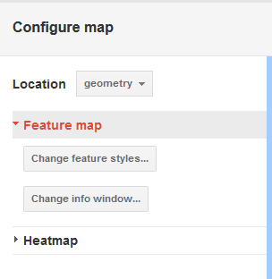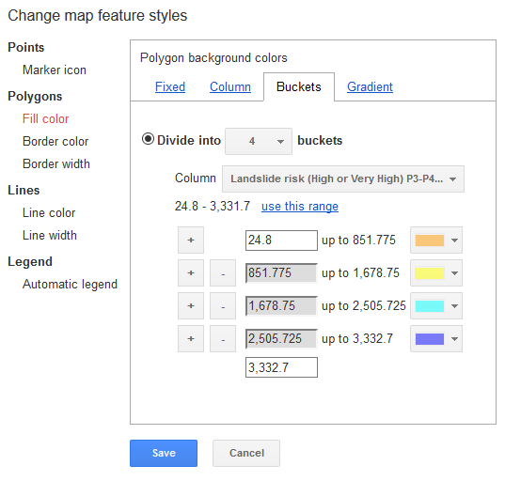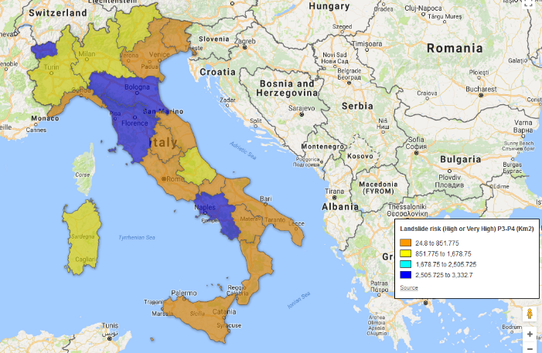

|  |  |  |  |  |  |  |  |  |  |  |  |  |  |  |
| --- | --- | --- | --- | --- | --- | --- | --- | --- | --- | --- | --- | --- | --- | --- |
| **Region** | **Area** | **Landslide risk (High or Very High) P3-P4** | | **Flood risk (Medium) P2** | | **Municipalities** | **Municipalities with landslide risk (P3-P4)+ flood risk (P2)** | | **Area surface with landslide risk (P3-P4)+ flood risk (P2)** | | **Cultural heritage with potential landslide risk (P3-P4)** | | **Cultural heritage with potential flood risk (P2)** | |
| **Km2** | **Km2** | **%** | **Km2** | **%** | **N.** | **N.** | **%** | **Km2** | **%** | **N.** | **%** | **N.** | **%** |
| Piedmont | 25.387 | 1.515,7 | 6,0% | 1985,3 | 7,8% | 1.206 | 1.131 | 93,8% | 3.412,1 | 13,4% | 658 | 5,0% | 1.261 | 9,7% |
| Aosta Valley | 3.261 | 2.671,7 | 81,9% | 231,7 | 7,1% | 74 | 74 | 100,0% | 2.712,9 | 83,2% | 206 | 58,7% | 48 | 13,7% |
| Lombardy | 23.863 | 1.450,3 | 6,1% | 2.021,5 | 8,5% | 1.544 | 1.173 | 76,0% | 3.347,4 | 14,0% | 280 | 1,9% | 972 | 6,5% |
| Trentino-Alto Adige | 13.605 | 1.398,9 | 10,3% | 80,8 | 0,6% | 333 | 295 | 88,6% | 1.471,6 | 10,8% | 82 | 4,7% | 8 | 0,5% |
| Veneto | 18.407 | 105,6 | 0,6% | 1.758,3 | 9,6% | 581 | 374 | 64,4% | 1.863,7 | 10,1% | 108 | 0,5% | 4.169 | 18,2% |
| Friuli-Venezia Giulia | 7.862 | 188,2 | 2,4% | 590,6 | 7,5% | 218 | 184 | 84,4% | 778,6 | 9,9% | 83 | 1,8% | 497 | 10,5% |
| Liguria | 5.416 | 812,7 | 15,0% | 143,7 | 2,7% | 235 | 235 | 100,0% | 954,2 | 17,6% | 856 | 6,1% | 3.236 | 23,1% |
| Emilia-Romagna | 22.452 | 3.331,7 | 14,8% | 10.251,2 | 45,7% | 348 | 348 | 100,0% | 13.550,0 | 60,3% | 1.044 | 4,5% | 13.274 | 56,6% |
| Tuscany | 22.987 | 3.062,6 | 13,3% | 2.550,2 | 11,1% | 287 | 287 | 100,0% | 5.521,4 | 24,0% | 1.457 | 9,1% | 3.125 | 19,6% |
| Umbria | 8.464 | 24,8 | 0,3% | 337,8 | 4,0% | 92 | 82 | 89,1% | 362,5 | 4,3% | 103 | 1,9% | 280 | 5,2% |
| Marche | 9.401 | 669,6 | 7,1% | 208,2 | 2,2% | 239 | 239 | 100,0% | 877,2 | 9,3% | 1.247 | 6,1% | 488 | 2,4% |
| Lazio | 17.232 | 805,2 | 4,7% | 522,4 | 3,0% | 378 | 321 | 84,9% | 1.325,6 | 7,7% | 565 | 4,4% | 335 | 2,6% |
| Abruzzo | 10.832 | 1.613,5 | 14,9% | 156,6 | 1,4% | 305 | 301 | 98,7% | 1.768,9 | 16,3% | 318 | 8,4% | 152 | 4,0% |
| Molise | 4.461 | 713,4 | 16,0% | 139,2 | 3,1% | 136 | 136 | 100,0% | 848,2 | 19,0% | 809 | 24,7% | 40 | 1,2% |
| Campania | 13.671 | 2.670,4 | 19,5% | 693,8 | 5,1% | 551 | 504 | 91,5% | 3.338,2 | 24,4% | 953 | 12,2% | 335 | 4,3% |
| Apulia | 19.541 | 584,1 | 3,0% | 819,3 | 4,2% | 258 | 234 | 90,7% | 1.401,0 | 7,2% | 360 | 4,8% | 235 | 3,1% |
| Basilicata | 10.073 | 510,3 | 5,1% | 261,3 | 2,6% | 131 | 131 | 100,0% | 770,1 | 7,6% | 188 | 10,5% | 30 | 1,7% |
| Calabria | 15.222 | 347,8 | 2,3% | 576,3 | 3,8% | 409 | 408 | 99,8% | 914,1 | 6,0% | 429 | 10,1% | 180 | 4,2% |
| Sicily | 25.832 | 387,0 | 1,5% | 385,6 | 1,5% | 390 | 360 | 92,3% | 772,3 | 3,0% | 420 | 5,3% | 63 | 0,8% |
| Sardinia | 24.1 | 1.066,0 | 4,4% | 696,8 | 2,9% | 377 | 328 | 87,0% | 1.757,0 | 7,3% | 169 | 3,6% | 277 | 5,9% |

Congratulations!

You have successfully **completed** section #2 of the tutorial.

**Goal #3.1:** Create a point map from a single database **using** *Google Web Tables* open data

* Renewable energy

The renewable energy industry is empowered by innovation and technology. As a result of the rising global demand for renewable energies, countries are shaping the cities of the future to be more environmentally friendly and fossil-fuel free. In this tutorial we will map the production of renewable energies in Europe.

1. Open *Google Web Tables* and search “*Renewable energy Europe*”.
2. From the dropdown list, we will work using **option #1** *“Renewable energy in the European Union”*. Click on **“show more”**, **“export data”** and **“export to google sheets”**.

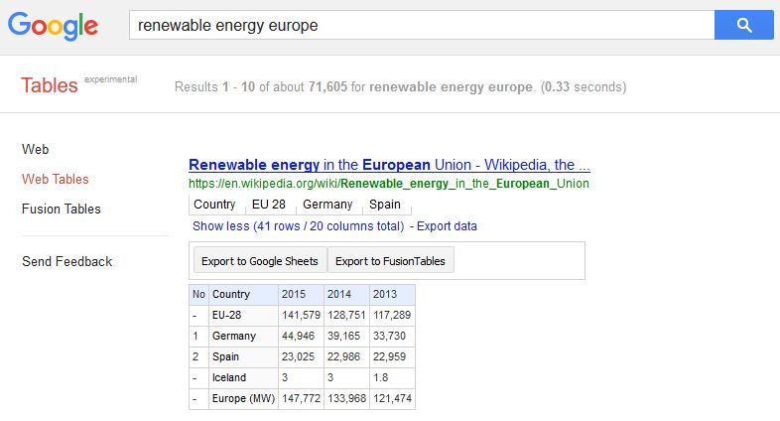

1. We need to make sure that the data is displayed in a correct way in order to be recognized by *Google Fusion Tables.* Sometimes this revision of data involves filtering and cleaning work. As we can see, some lines are not countries. Delete them to avoid problems of data visualization

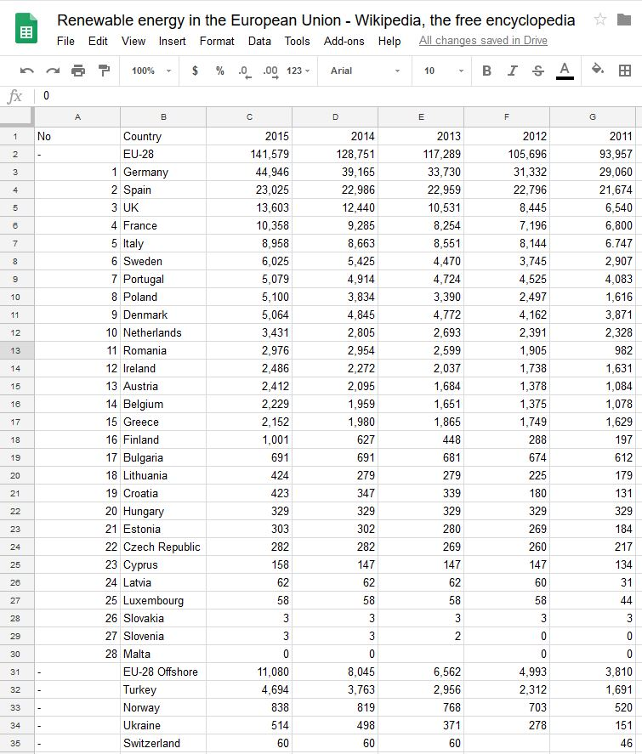

1. The database is ready for *Google Fusion Tables*. To import the table click [here](https://fusiontables.google.com/DataSource?dsrcid=implicit&pli=1). Click on *Google Spreadsheets* and select the file *“Renewable energy in the European Union”*. Now you’ll see the list of countries in *Google Fusion Tables.* Click on **“Map of Country”** to visualize the data in the map. Even if the data does not contain any geospatial reference, *Google Fusion Tables* automatically geocodes the addresses based on the location column, which in this case is **“Country”.**

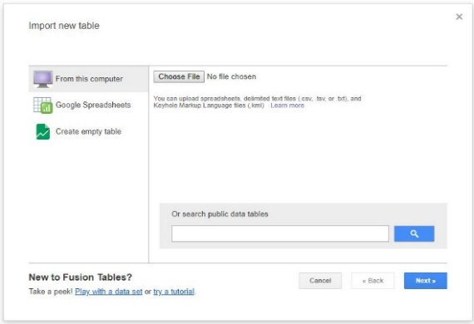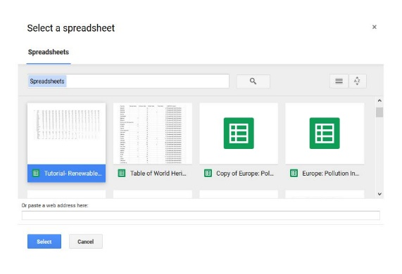

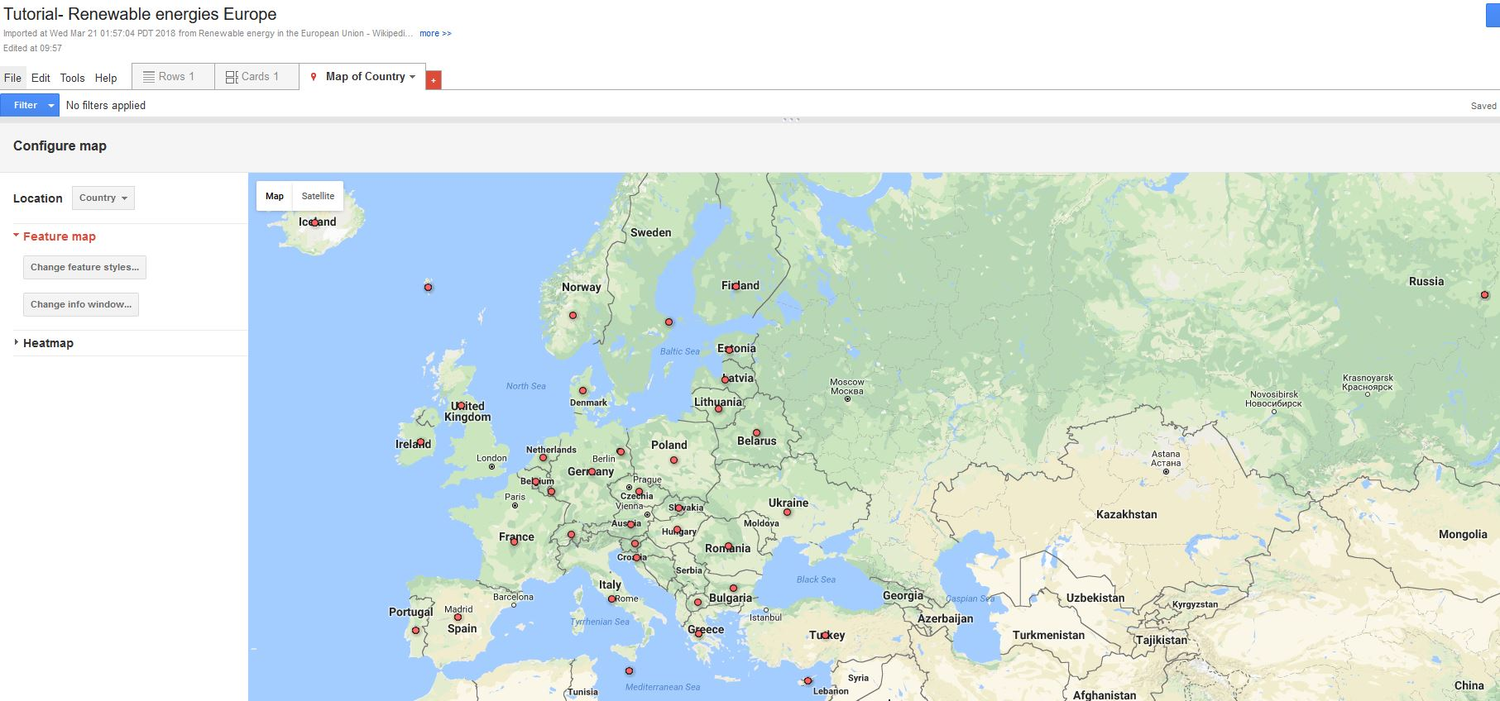

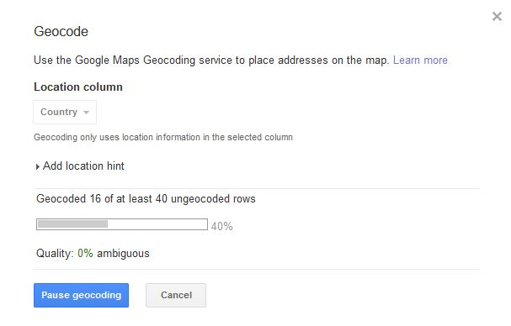

1. The function **“Change features styles”** enables all users to improve the visualization of the map by choosing from the variety of styles and colors based on the data available and values of your interest. Divide the buckets into **5 custom values** and select the **pin from red to purple**. **Activate the legend** and **change the info window layout** to only the country name and the latest value (2015).

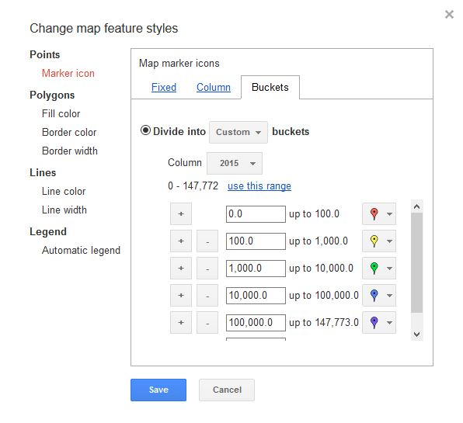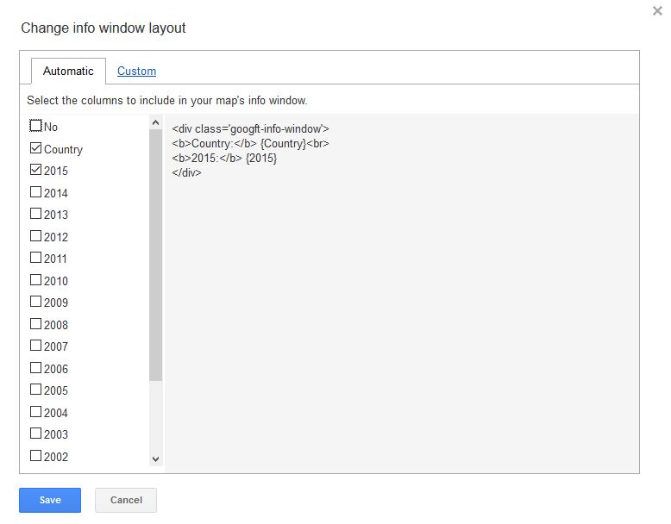

1. The finished product should look like

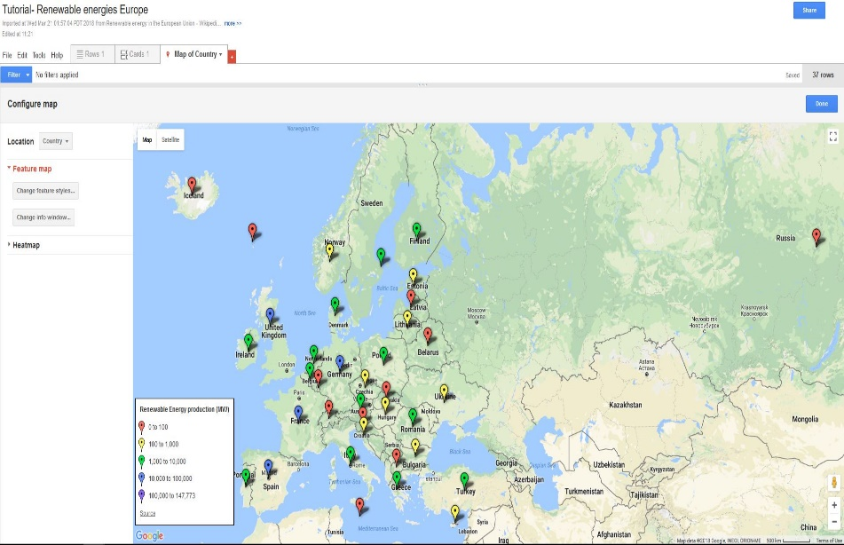

Congratulations!

You have successfully **completed** section #3.1 of the tutorial.

**Goal #3.2:** Create a point map **based on** *Google Web Tables* open data using an automatic procedure to separate data that cannot be mapped in the original format.

* Environmental risk

Air pollution is the greatest environmental risk to health in urban areas. In this tutorial we will concentrate in the use of open data indicators in Europe to classify the cities with the highest pollution index.

1. Open *Google Web Tables* and search “*Europe Pollution Index*”.
2. From the dropdown list, we will work using **option #2** *“Europe: Pollution Index by City 2015”*. Click on **“show more”**, **“export data”** and **“export to google sheets”**.

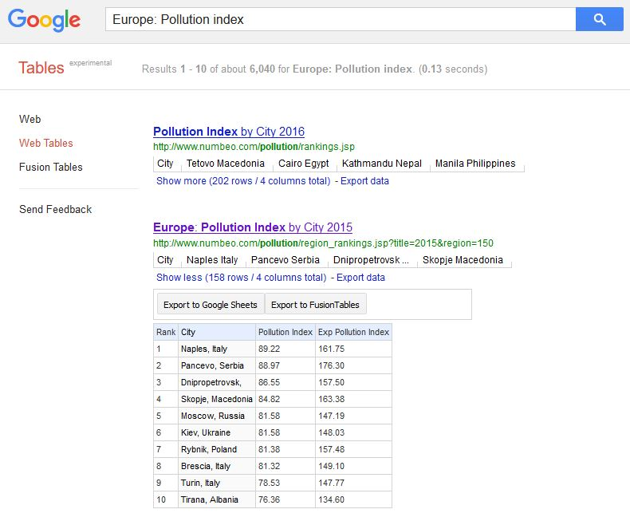

1. City and country are together in the same cell. Unfortunately *Google Fusion Tables* cannot map this data, unless two columns are created, one for cities and for countries respectively. When working with **big data**, users are highly recommended to **avoid manual procedures** because is **time consuming and typos** are likely to be **sources of errors**. **Automatic procedures** is the way to go to separate lists.

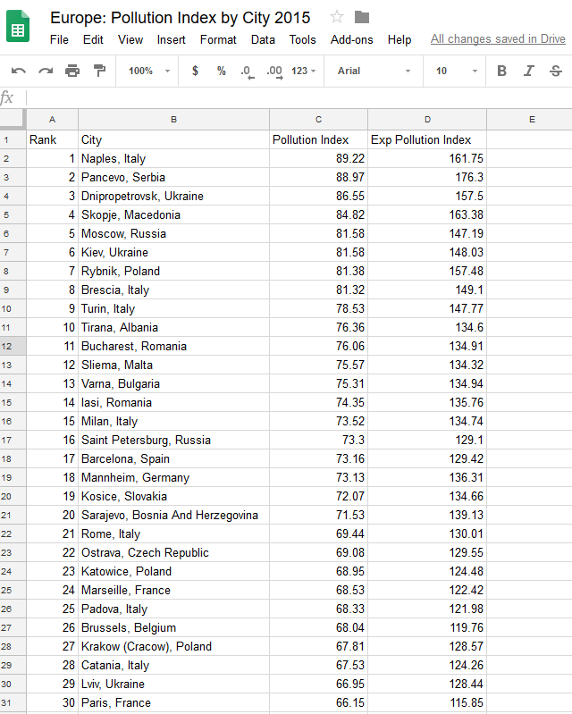

1. To start the automatic procedure, download the data as .csv file.

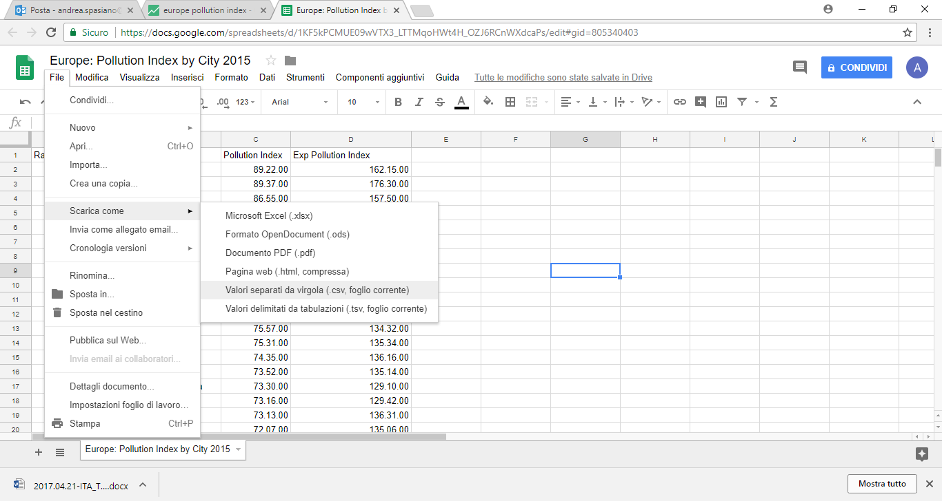

1. Move the file to a new folder and open as .txt file using the **Notepad**. The city and name are within quotation marks (“”). To separate both, click in **“modify”** and **“replace”**.

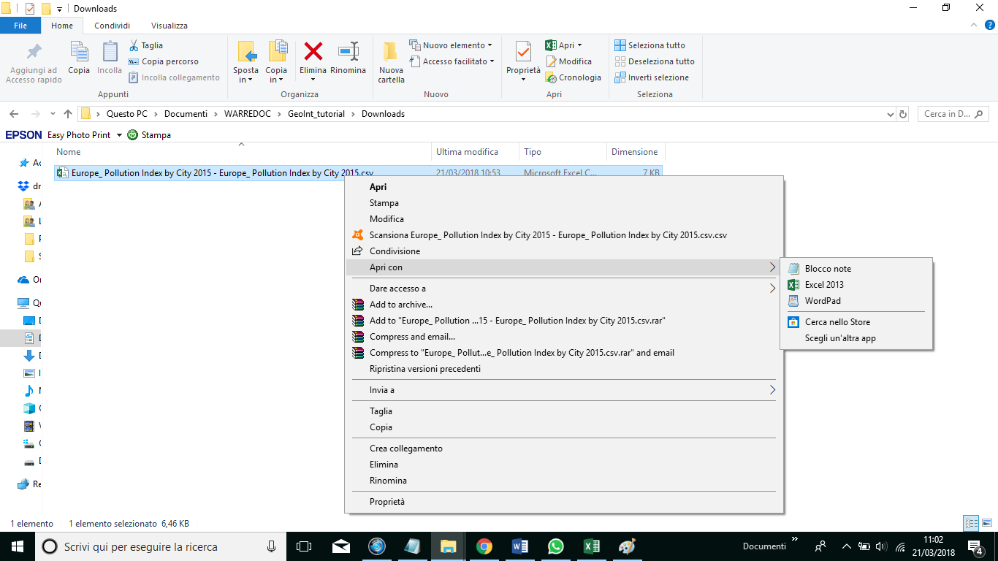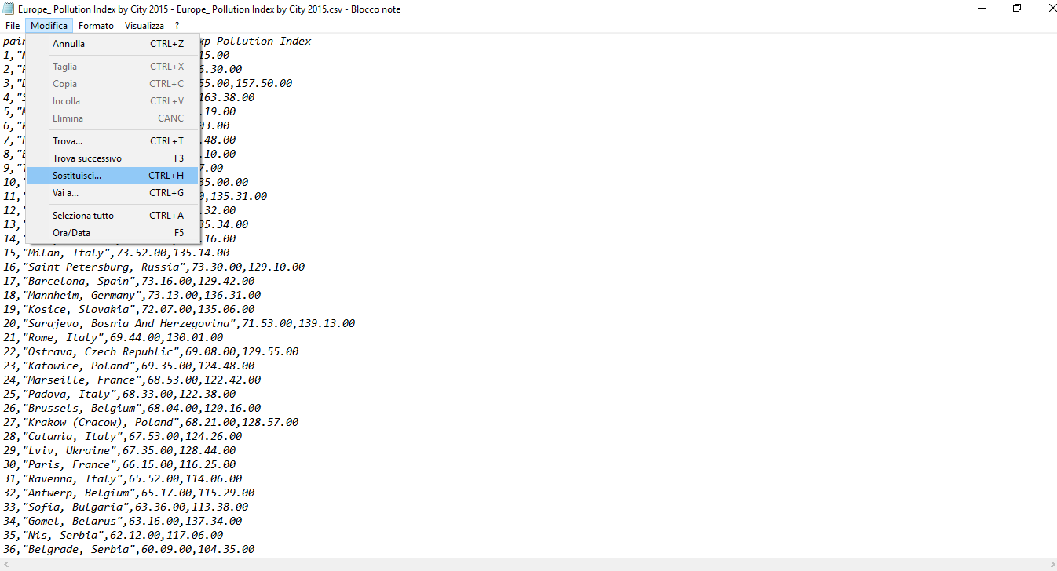

1. To erase the quotes fill the blanks as follows: **Find what:** “ (one quotation mark), **Replace with:**  (one single-space line) and “**Apply to all”**. Verify that the quotes are no longer in the file. Now add in the first line the word ***“Country”*** after the word ***“City”***. Save the file as **“Pollution Index”**.

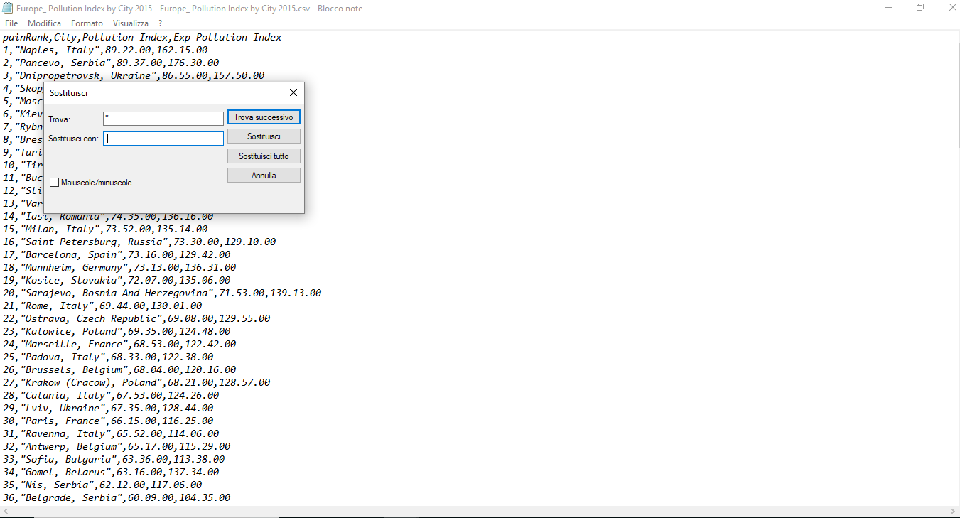

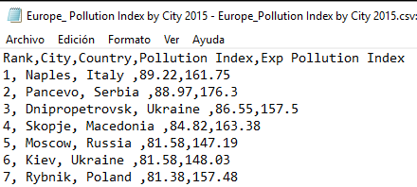

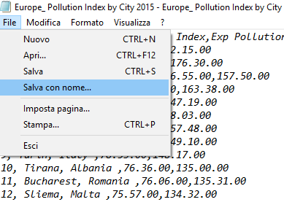

1. Now it’s time to visualize the data in separate columns. Open a new file excel and import the new text file by clicking on **“DATA”.**

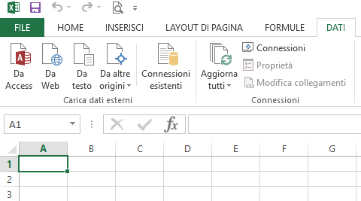

1. From the **Text Import Wizard** in the original data type menu choose delimited to split the data in columns and the row number 1, click next. Now select **“Tab”** and **“Comma”** to separate City and State from each other. Finally choose **“General”** in the column data format and save as **.csv file**.

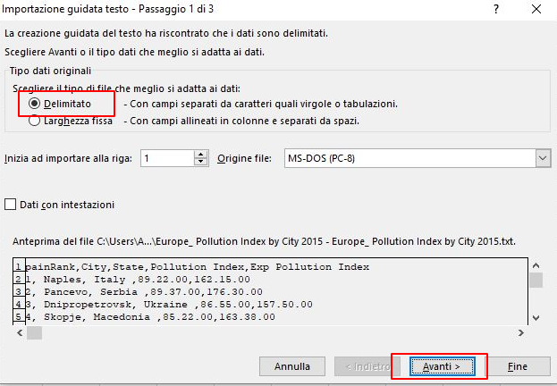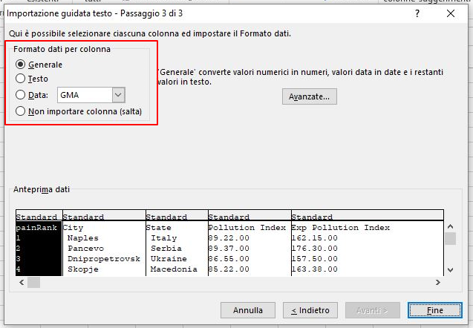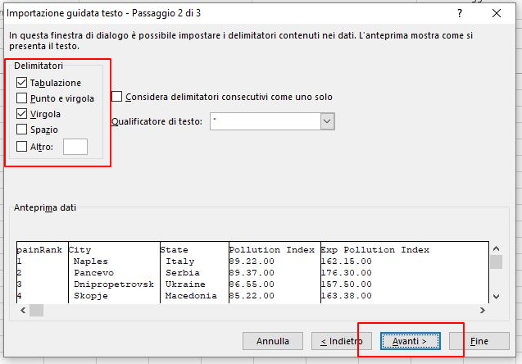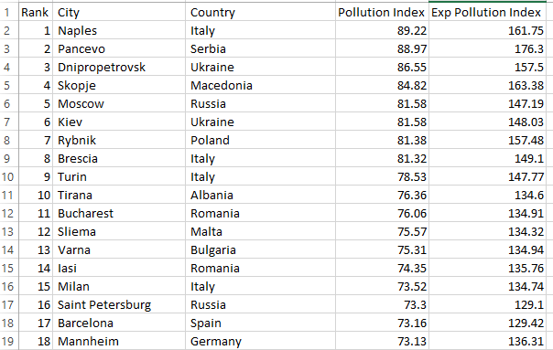

1. Now we are ready to create the **Air pollution Index Map** in *Google Fusion Tables*. In order to import the table from the computer, click [here](https://fusiontables.google.com/DataSource?dsrcid=implicit&pli=1) to choose the file. Choose “**Comma”** as separator character and rename the project.

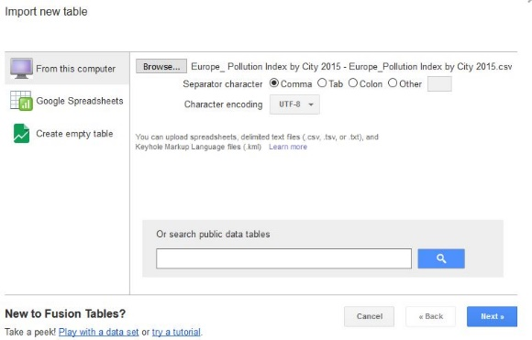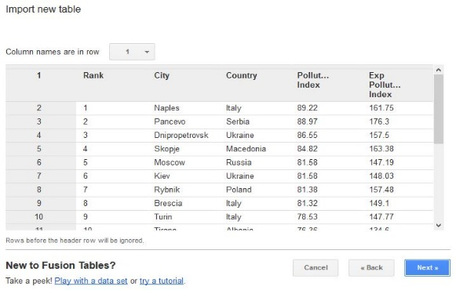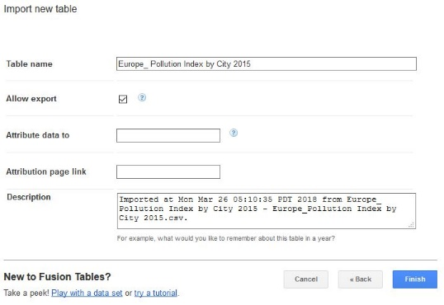

1. *Google Fusion Tables* can maps data based on three types of geocoding: **Country, Region, City and Coordinates (latitude, longitude)**. The goal of this tutorial is to visualize the air pollution by cities; therefore click on **Map of City** and select from **location** ***“City”***

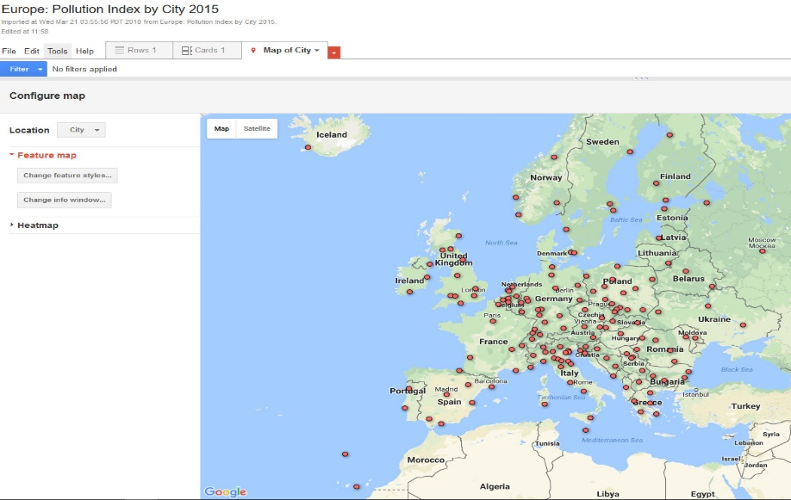

1. You can easily improve map visualization by using the function **“Change features styles”**. Choose from the variety of styles and colors based on the data available and values of your interest. Categorize the indicators from 1 to 10 groups and change the range of the buckets. For this tutorial select 4 buckets and include the legend in the lower left corner.

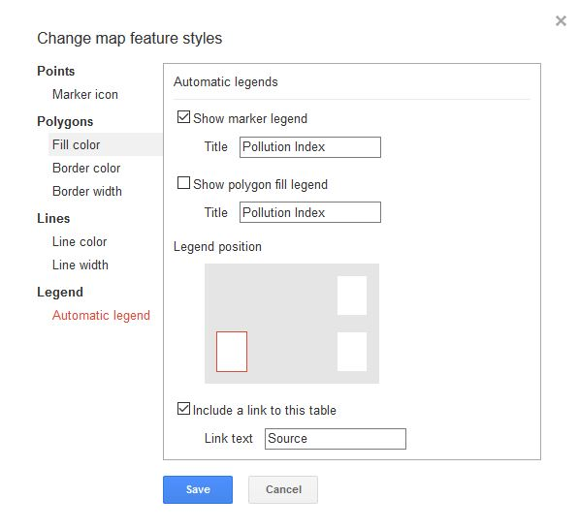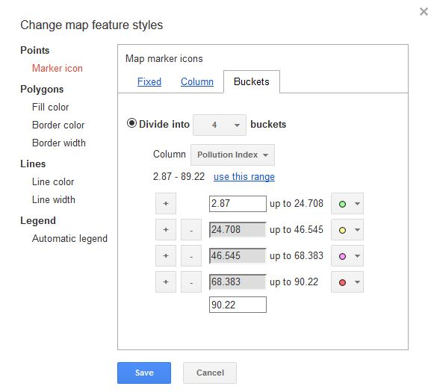

1. The following **maps depict** **two visualization types available** in *Google Fusion Tables*. The first display the classification of values in 4 groups and the second a cluster **“Heatmap”** as a way of illustrate intensity of air pollution in each country. Heatmaps enable the user to edit the radius, opacity and weight, proving flexibility to the author on how to better represent data for an audience.

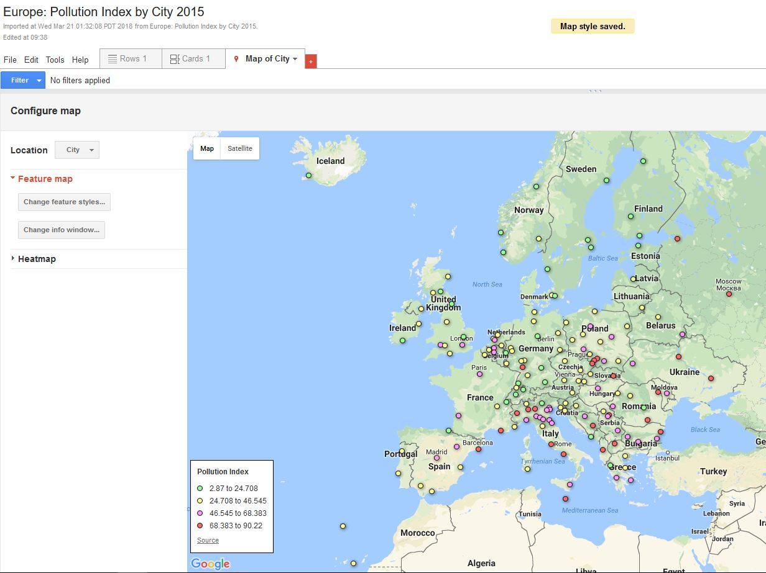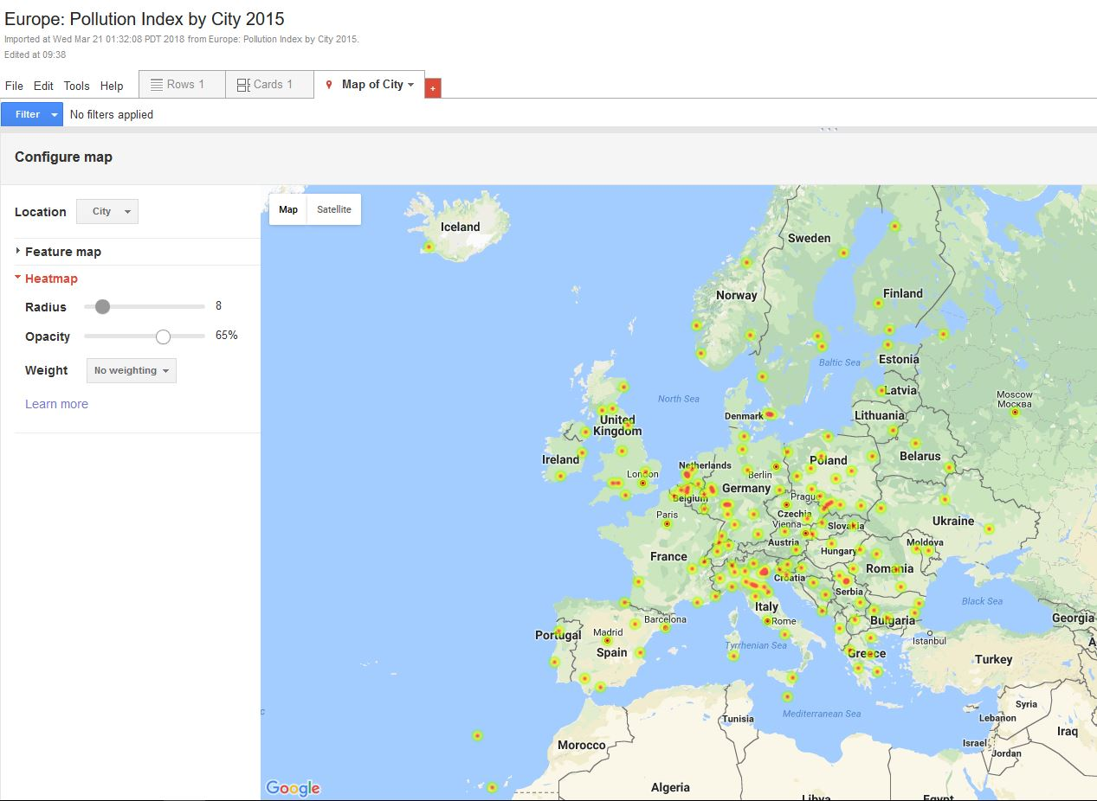

Congratulations!

You have successfully **completed** section #3.2 of the tutorial.

**Goal #3.3:** Create maps for any sector **using** *Google Web Tables* open data.

* Territory and landscape

The landscape is the manifestation of the human identity in the territory, a result from centuries of the interaction between culture and adaptation to the environmental. The most valuable landscapes in the world are protected and part of the list of UNESCO World Heritage Sites as a common heritage of mankind. In this tutorial we will focus on mapping only the UNESCO World Heritage Sites in Europe.

1. Open Google and make sure you are logged in. In case you need to create a new account click [here](https://accounts.google.com/signup/v2/webcreateaccount?service=fusiontables&continue=http%3A%2F%2Fwww.google.com%2Ffusiontables%2FHome&flowName=GlifWebSignIn&flowEntry=SignUp)
2. Open [*Google Web Tables*](https://research.google.com/tables) and search “Unesco World Heritage Sites Europe”. From the dropdown list, we will work using **option #3** *“Table of World Heritage Sites by country”*. Click on **“show more”**, **“export data”** and **“export to google sheets”**.

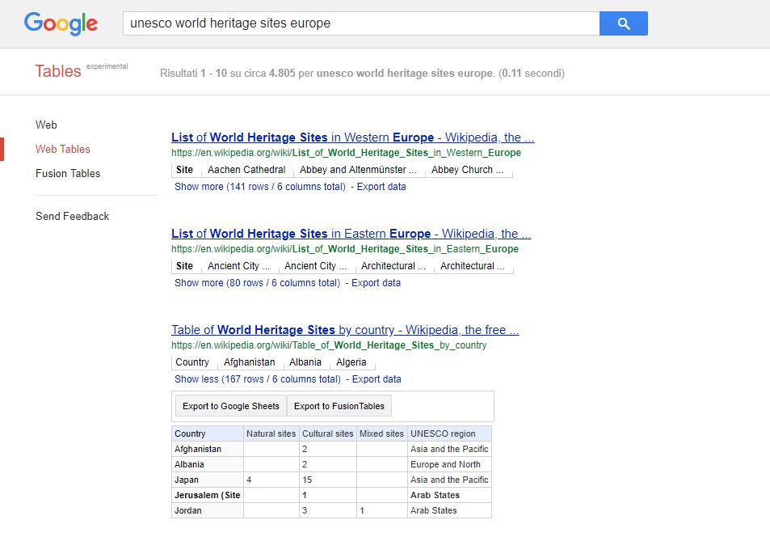

1. Keep in mind that open data may come with additional information, typos and errors that we need to address before mapping. We are interested in mapping the countries from all Europe. Considering that filtering and cleaning procedures are time consuming we should be flexible when we reach a particular goal, to take advantage of the information available and maximize time efficiency. Saying this, we can see that countries are organized in **five UNESCO regions**:
   * 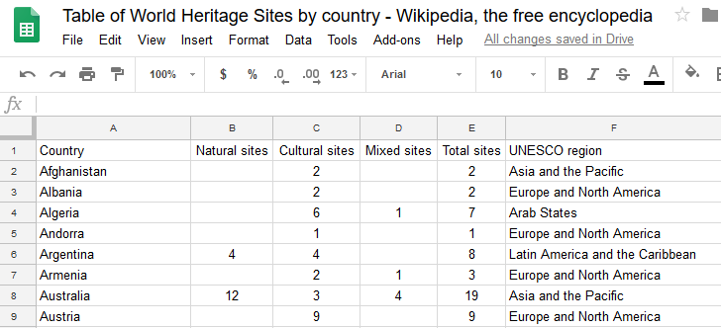**Asia and the Pacific**
   * **Europe and North America**
   * **Arab States**
   * **Latin America and the Caribbean**
   * **Africa**
2. After careful evaluation to determine an automatic data filtering procedure, the best solution is to map the Europe UNESCO region. To do this, move the mouse cursor to the **F column**, click on the dropdown box and select **sort sheet A – Z**. Now that all countries are organized by regions, we need to delete all except Europe and North America. To perform this task, select the countries that you are not interested, then right click in the ID column number and select delete row. To finalize the editing, manually erase the extra lines that are not countries, including Canada and United States, to map the Europe UNESCO Region with a total of 48 countries. Change the file name to **Tutorial: UNESCO World Heritage Sites Europe.**

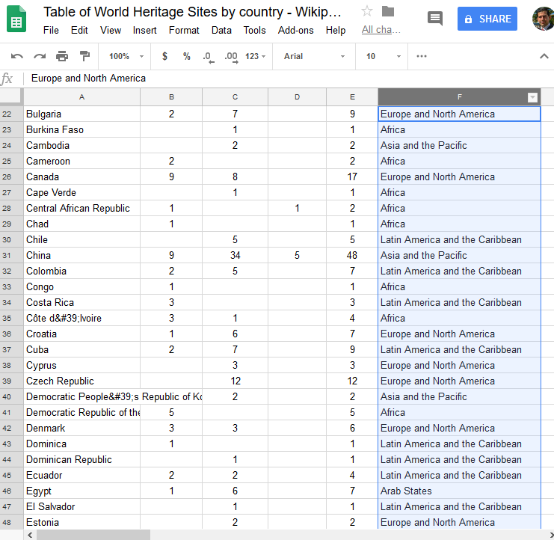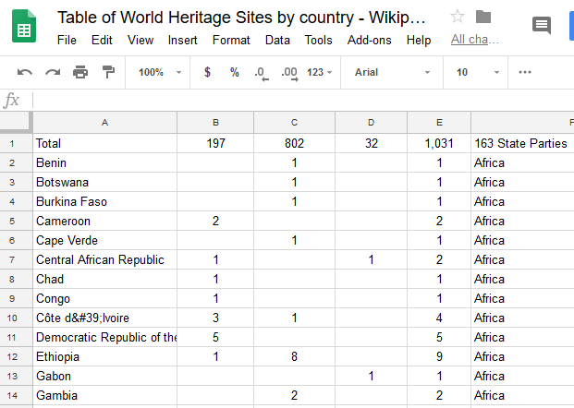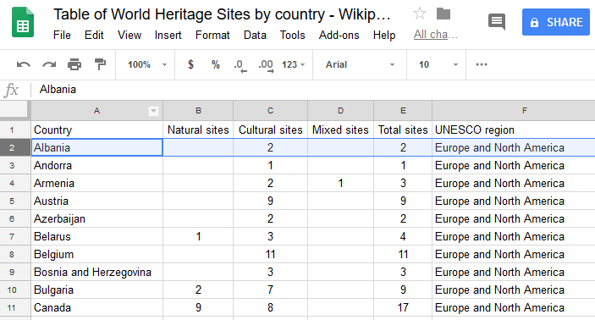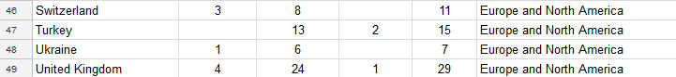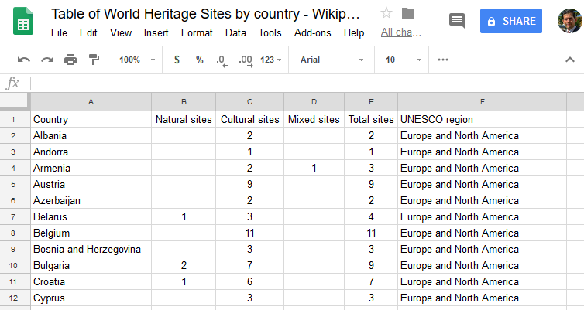

1. 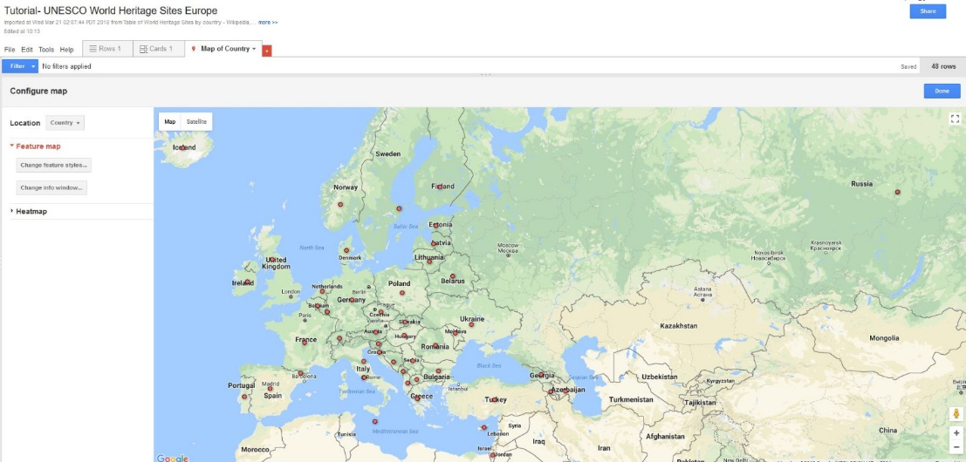The database is ready for *Google Fusion Tables*. To import the table click [here](https://fusiontables.google.com/DataSource?dsrcid=implicit&pli=1). Click on **“Map of Country”** to visualize the data in the map

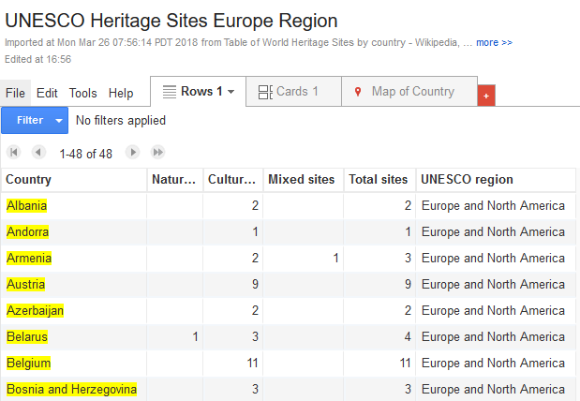

1. Put your creativity into action to improve the visualization of your map. Change the color and format of features and display the buckets as desired, including the legend.

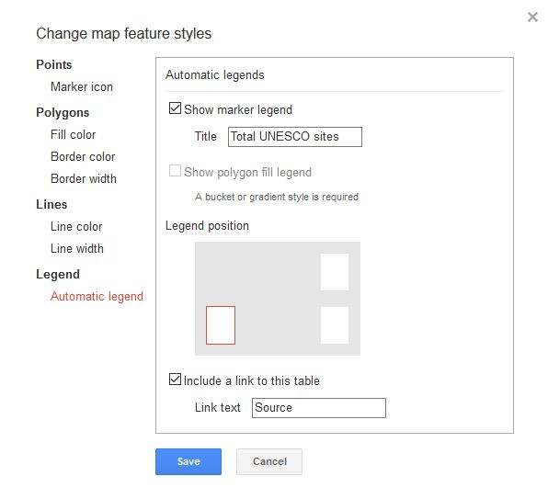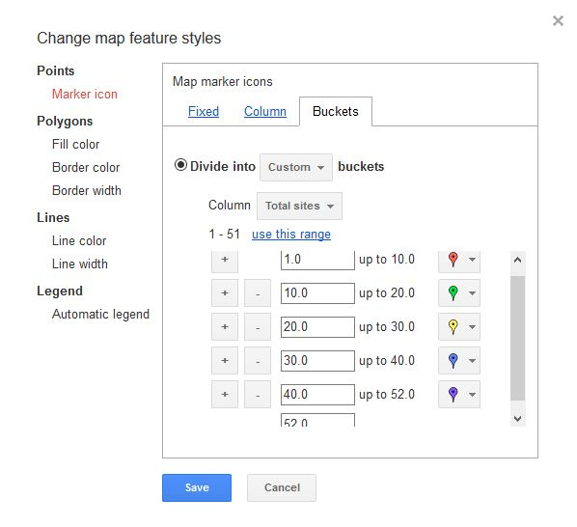

1. 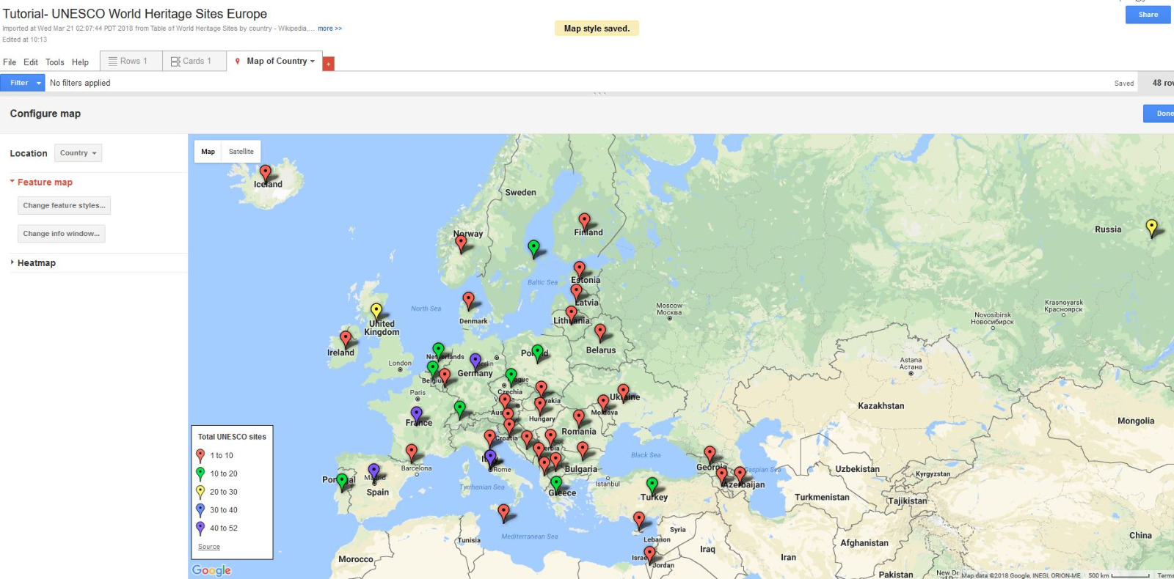The finished product should look like

Congratulations!

You have successfully **completed** section #3.3 of the tutorial.

**Goal #3.4:** Create a point map from a single database **using two sets of** *Google Web Tables* open data

* Tourism and cultural heritage

Transport infrastructure and cultural heritage are among key factors for tourism development and management. In this tutorial we will focus on mapping the main airports and art galleries in Europe. First, to separate maps will be created and ultimately merged in order to obtain a single database of European cities that are attractive for tourist because of their accessibility and cultural heritage.

1. Open [*Google Web Tables*](https://research.google.com/tables) and search “List airport Europe”. From the dropdown list, we will work using **option #1** *“List of the busiest airports in Europe”*. Click on **“show more”**, **“export data”** and **“export to google sheets”**.

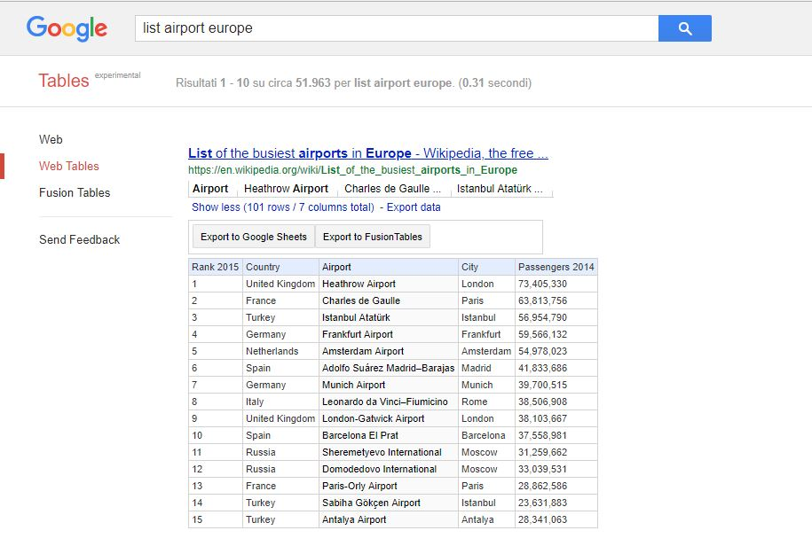

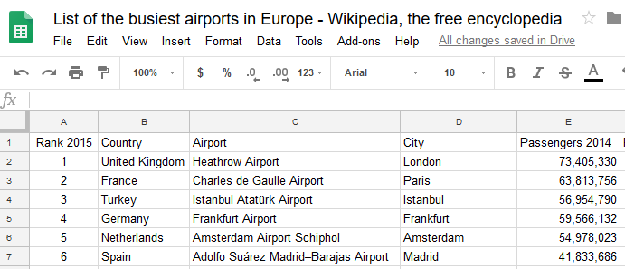

1. 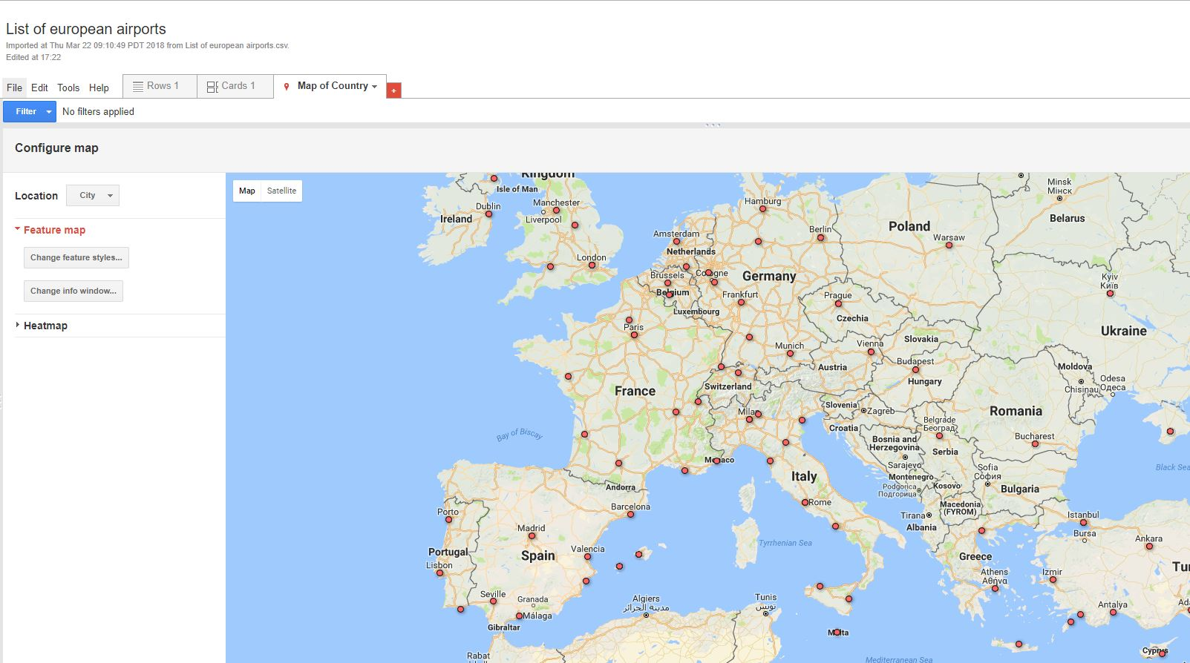We can confirm that the data is organized by country, airport and city. As previously mentioned, *Google Fusion Tables* can automatically geocoded any list with this characteristics. Now we are ready to create the **European Airports Map** in *Google Fusion Tables*. In order to import the table from the computer, click [here](https://fusiontables.google.com/DataSource?dsrcid=implicit&pli=1) to choose the file from the *Google Spreadsheets* library. Once the data appears in the screen, click on **Map of City** and select from **location** ***“City”***

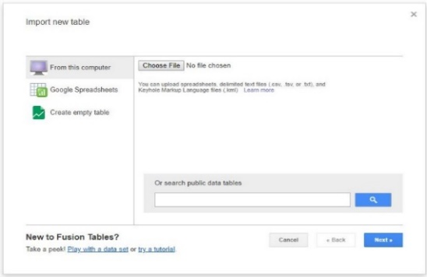

1. 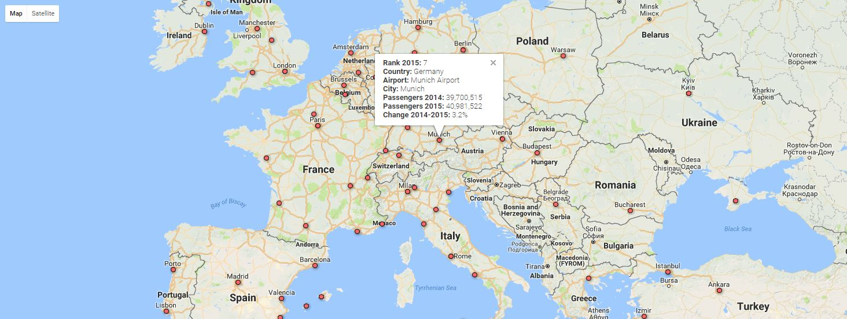Tailor the pop-up window by selecting **change info window**, **change feature styles as preferred** or use the **“Heatmap”** to visualize the concentration of passengers for each airport.

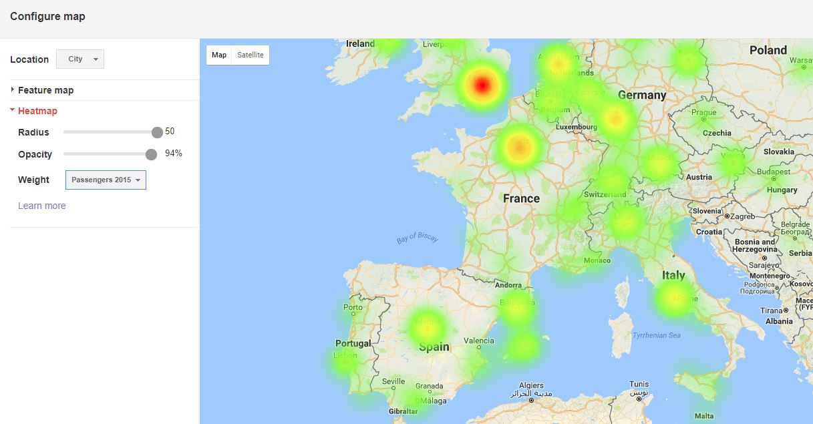

1. We are not done yet. This information needs to be merged with the list of most visited art museum. Integrating both datasets can provide a better understanding of which cities are more appealing to art tourists.
2. Before proceeding with the tutorial, do not close any of the previous tabs you were working earlier. This is important to understand the merge procedure. Open a new [*Google Web Table*](https://research.google.com/tables) and search “List museums Europe”. From the dropdown list, we will work using **option #1** *“List of most visited art museums in the world”*. Click on **“show more”**, **“export data”** and **“export to google sheets”**.

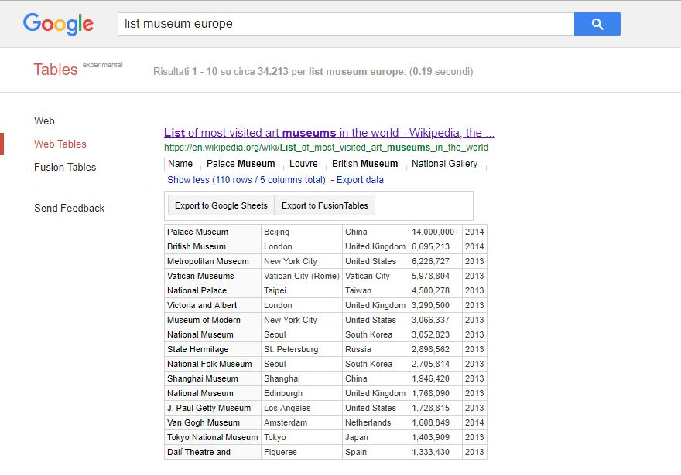

1. Repeat **step #2 and #3** to visualize the most visited museums.

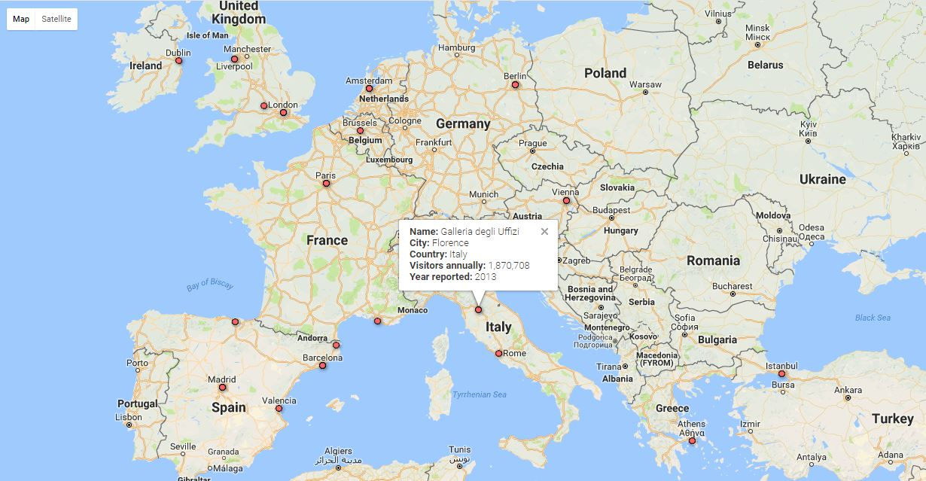

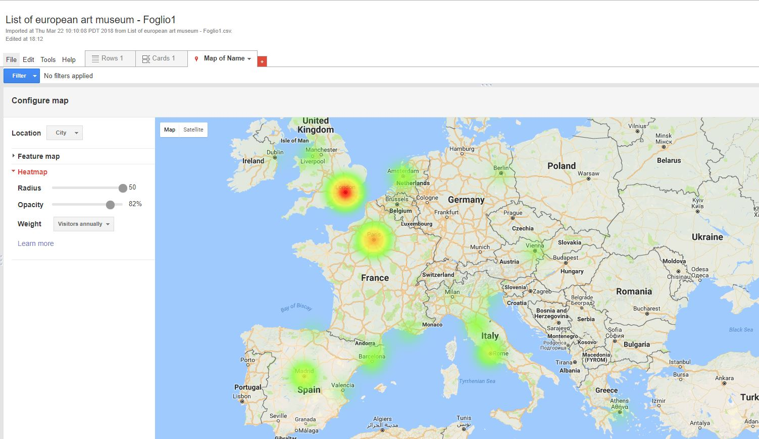

1. To merge both data click on the red cross **(+)** next to **Map of Name** and select “**Add map”**. Then click on **“file”, “merge”** and select the *‘List of busiest airports’* that is stored in the Gdrive.

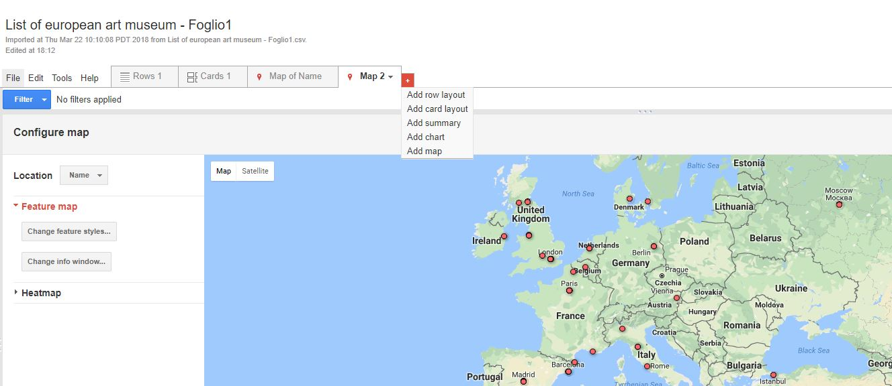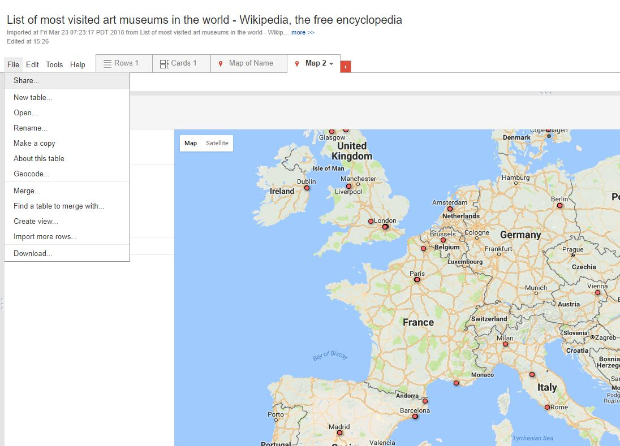

1. To confirm the data association, select for both fields ***“City”*** and click **“Next”**.

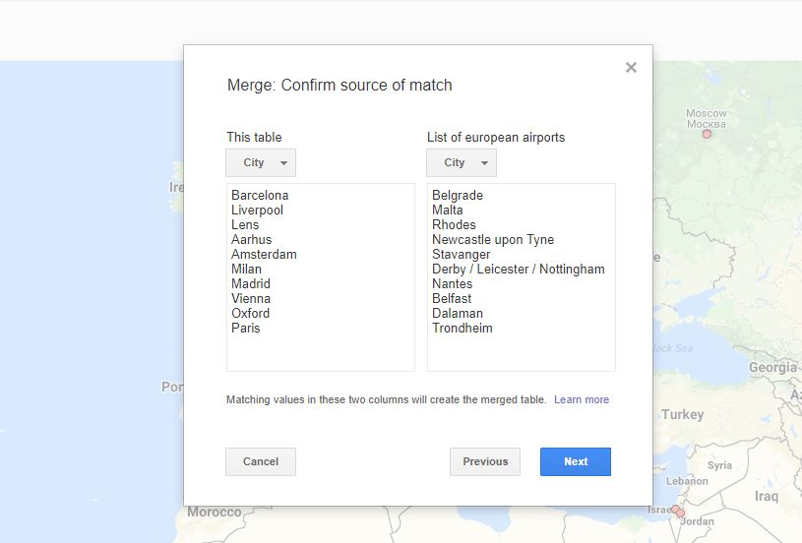

1. The new map contains information from both database tables *“List of the busiest airports in Europe”* and *“List of most visited art museums in the world”.*

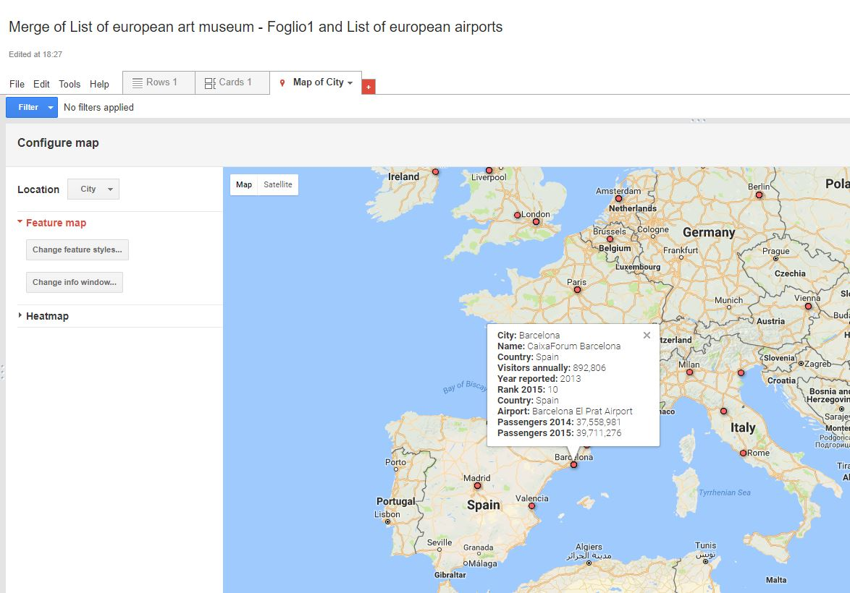

Congratulations!

You have successfully **completed** section #3.4 of the tutorial.

**Goal #3.5:** Create a color map from a single database **using** *Google Web Tables* and *Google Fusion Tables.*

* **Water Resources**

Water is an essential element for life, however water accessibility around the world is shaped by differences in wealth, environment and political systems. As a result, is not always accessible to all the population, in particular the gap between developed and developing countries.

1. Open [*Google Web Tables*](https://research.google.com/tables) and search “Water accessibility index”. From the dropdown list, we will work using **option #1** *“Improved water source (% of population with access)”*. Click on **“show more”**, **“export data”** and **“export to google sheets”**.
2. The data for each country has been found but the file lacks geospatial data. In a **different search window** click on *Google Fusion Tables* and type ***“Country Boundaries.kml”***. From the dropdown list, we will work using **option #3** *“World Country Boundaries”*.

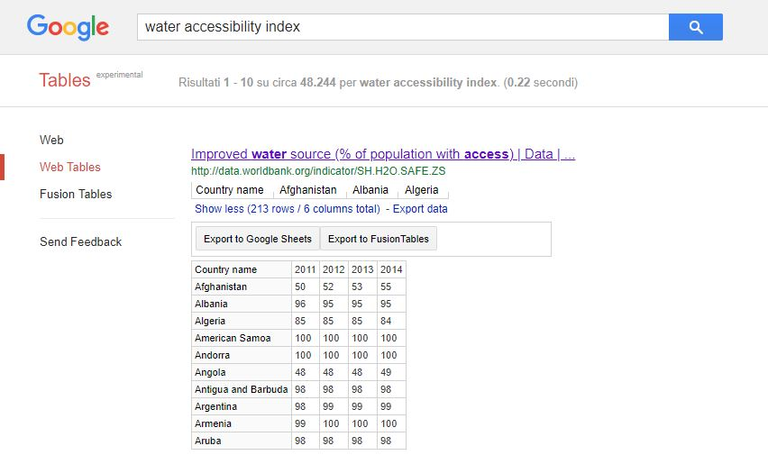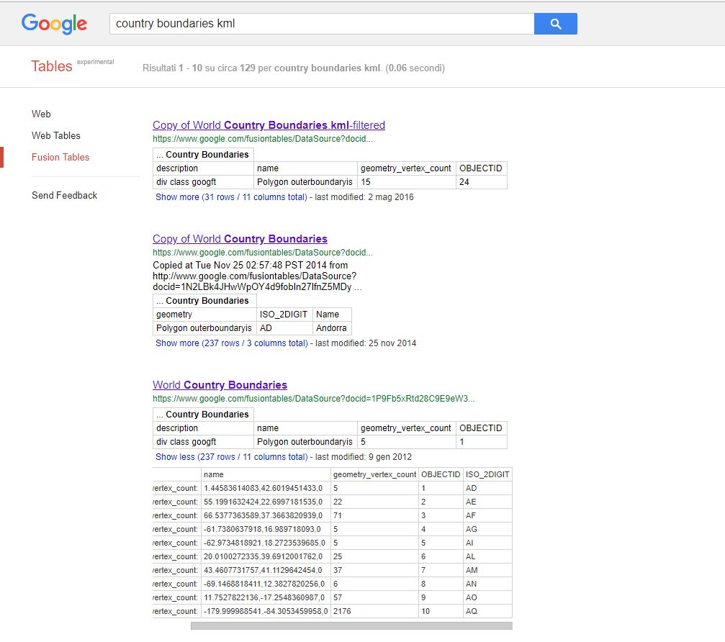

1. Open the file to confirm the table contains geospatial coordinates (kml geometry) of each region are correct. To visualize the color map click on ***“Switch to new look”***, located in the upper right corner.

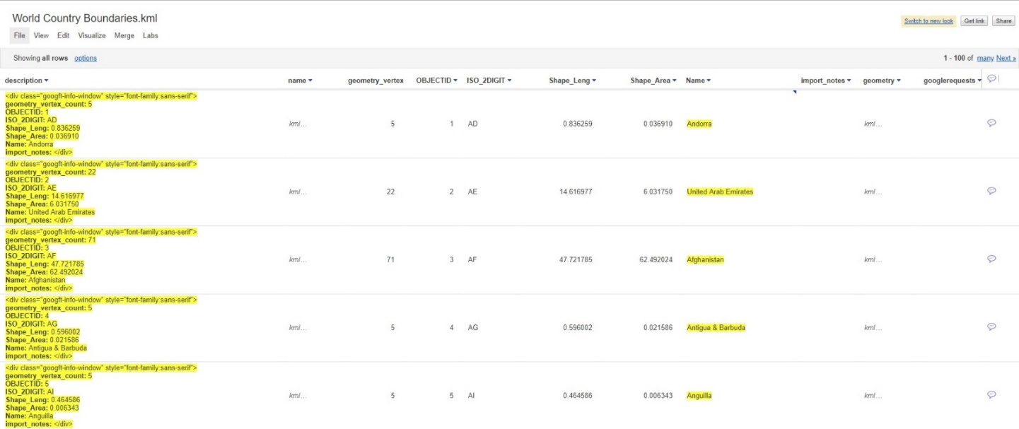

1. Now that you can visualize the full color map of the world, it’s time to associate the country geometry file with the water accessibility list. Click on file and merge it with the data stored in the Gdrive.

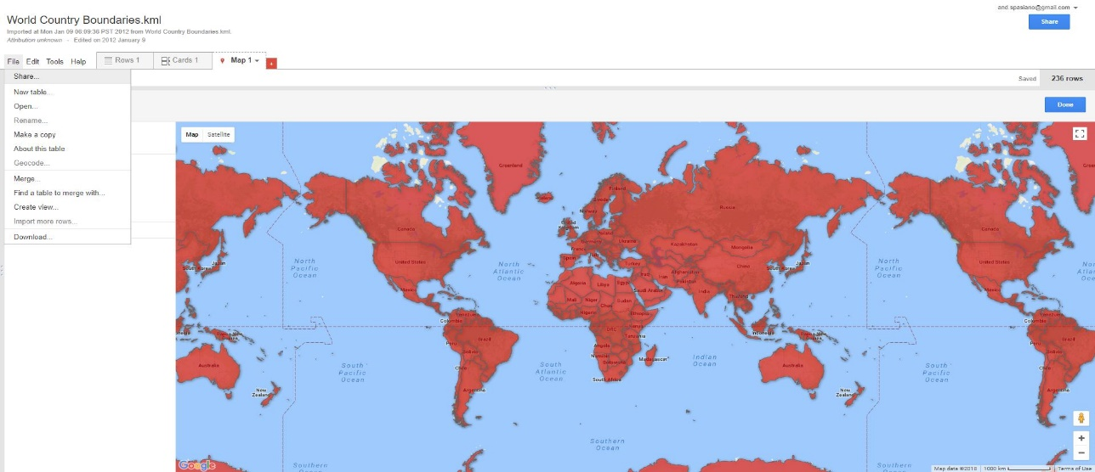

1. Before proceeding with the merge of both tables, it’s important to **verify the source of match**. In this case, we are interested in merging data for each **country**. Therefore, select from the “*World boundaries”* tablethe field **“Name”** and from *“Improved water source”* list, **“Country name”** respectively. A confirmation message of the new merge table will appear on the screen, click on *“****view new table”***. Don’t forget to tailor the map as desired. The finished product should look like

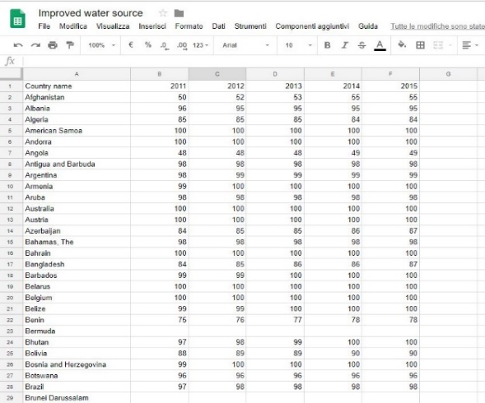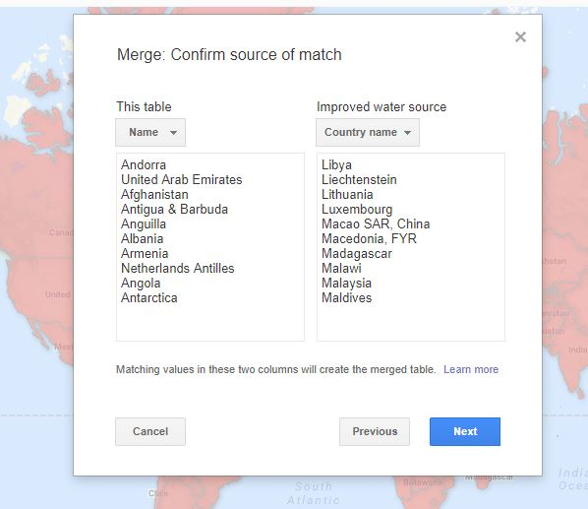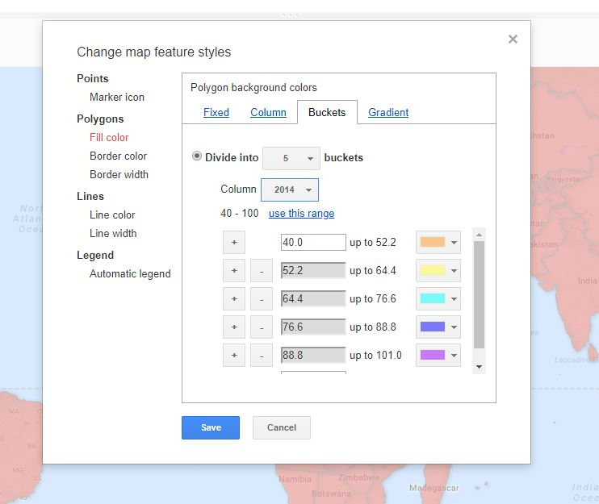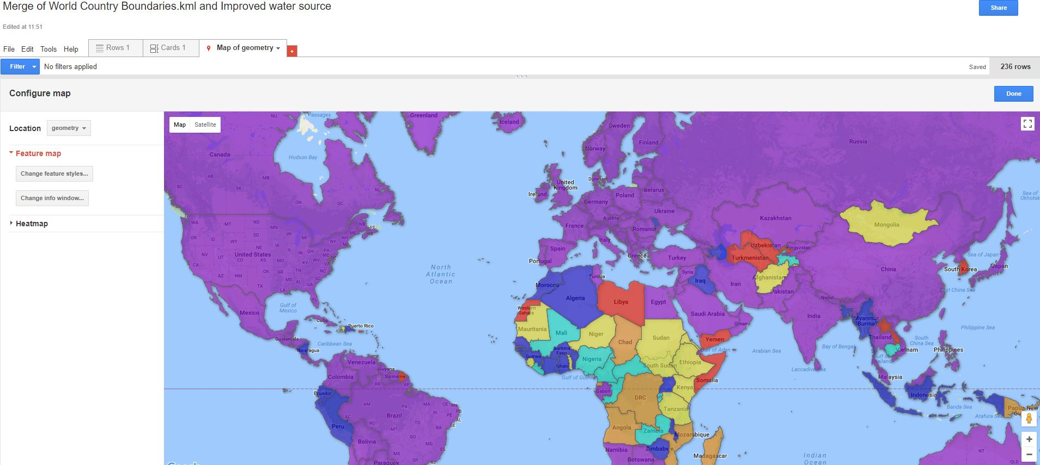

Congratulati

Congratulations!

You have successfully **completed** section #3.5 of the tutorial.